Sabre Sharpening, LLC- Price List and Order Form
www.sabresharpening.com
www.facebook.com/sabredentalsharpening
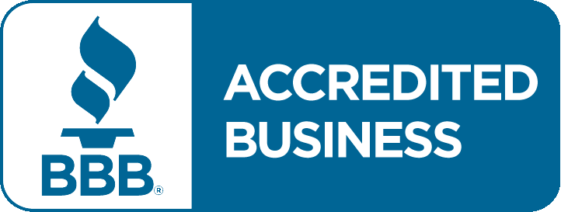
Instrument (per end) | Description | Price | Qty
Hygiene Instruments- Scalers Curettes and Graceys | Restore original blade angle and polish | 1.00
Explorers | Sharpen and polish points | 1.00
Excavators, Carvers, Pluggers and  Condensors | Restore original blade angle and polish | 1.00
Composite Instruments | Polish, smooth and reshape blades | 1.00
Scissors | Restore original blade angle and polish | 4.00
Periodontal- Knives, Bone Files Chisels and Surgical Curettes | Sharpen, polish and reshape blade angle | 4.00
Periosteals | Polish, reshape blade angles and remove nicks | 6.00
Elevators | Restore original blade angle and polish | 4.00
Surgical Suctions | Reshape tip, polish and remove nicks | 6.00
Ortho Cutters | Polish, sharpen and remove nicks | 15.00
Forceps | Remove burs and nicks from jaws | 8.00
 | Re-tipping (+ shipping and tax)
Hygiene Instruments | General, non-surgical | 4.50
All Other Instruments |  | Quote

Mailing Address: Your Information:
Sabre Sharpening, LLC
119 Jesse Brown Drive ____________________________________________
Goodlettsville, TN 37072
615-347-5443
brandon.nicholson3@gmail.com ____________________________________________

For instruments that are beyond repair:
____________________________________________
- Send back with my order
- Call our office before order is processed
- Dispose of instrument ____________________________________________

